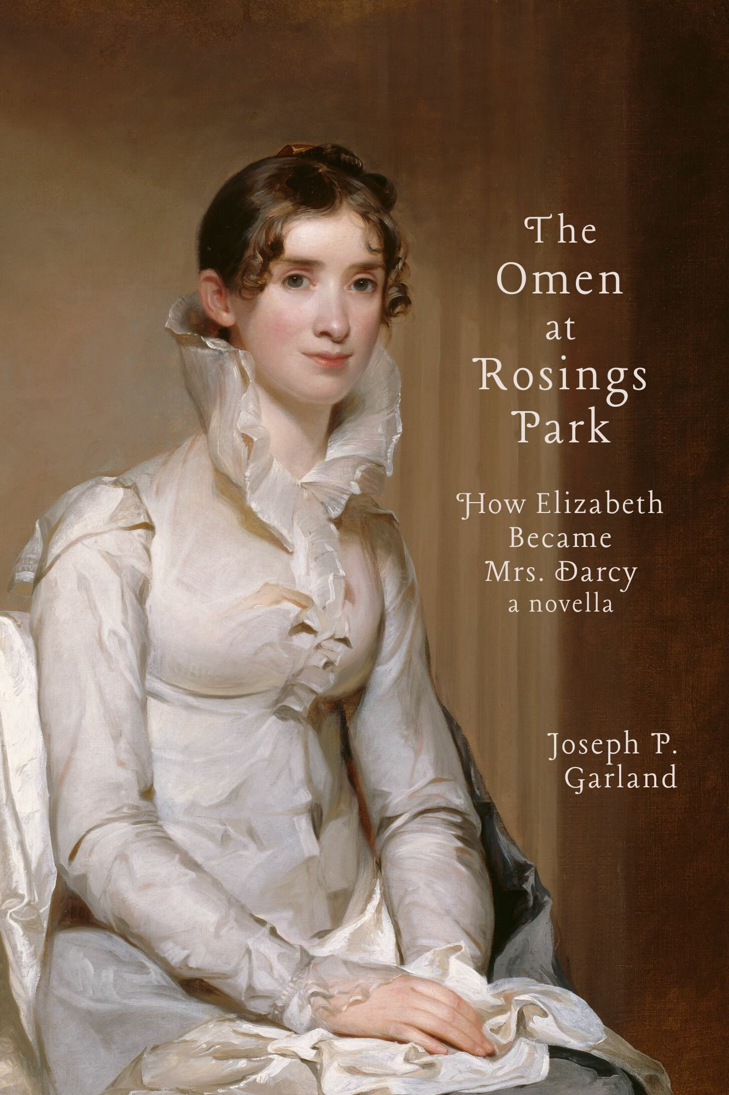

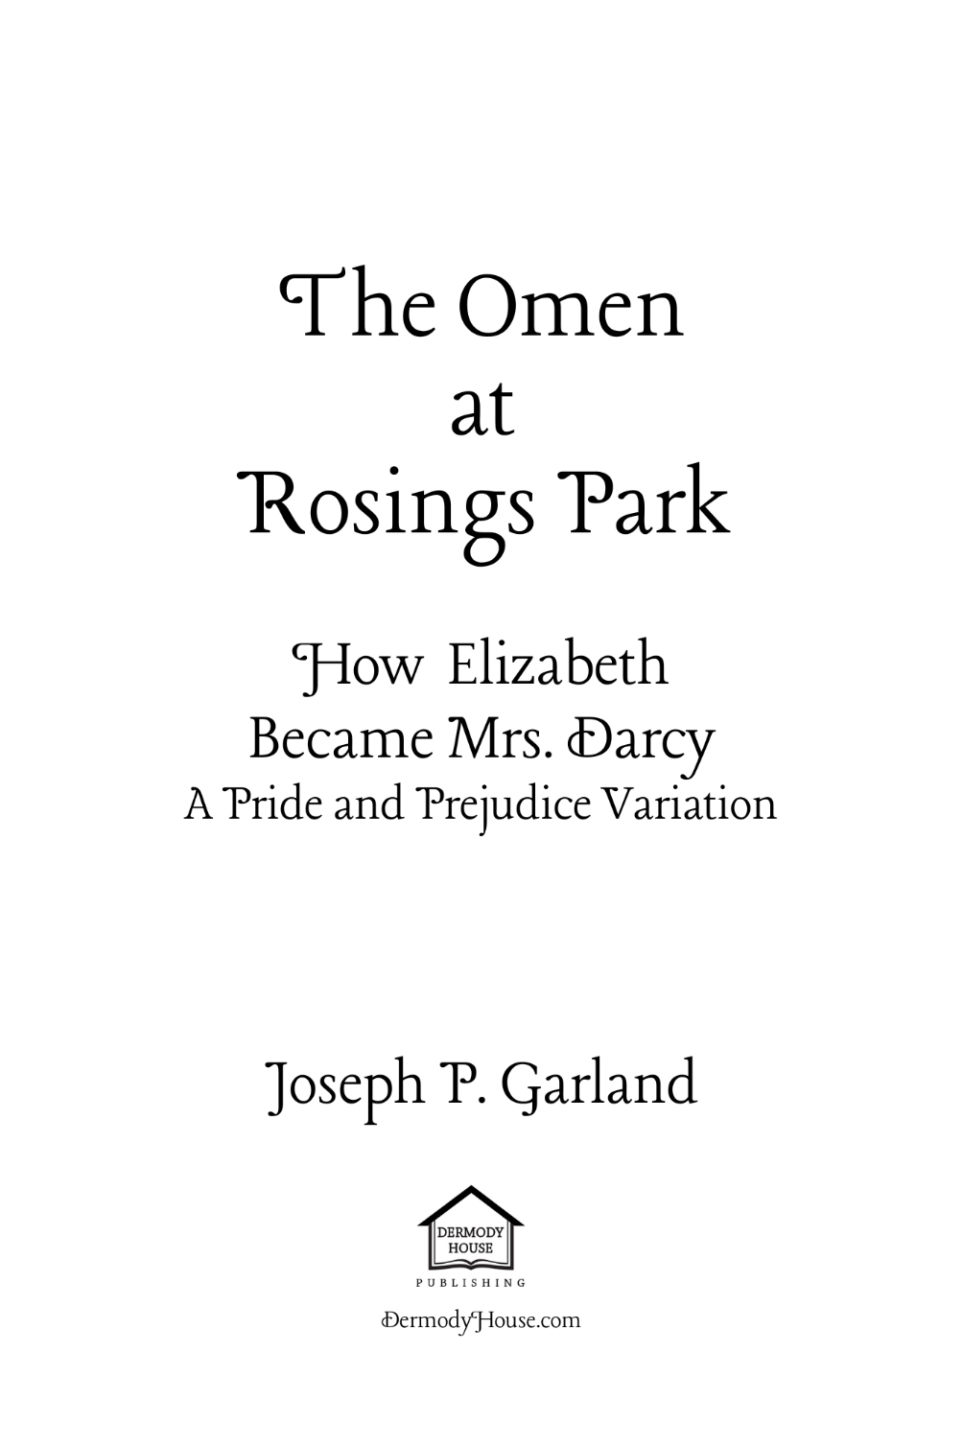

Introduction
T
his is a Pride and Prejudice Variation. Unlike my first novel related to that novel, Becoming Catherine Bennet, this novella makes a major alteration in the original. I have attempted to match the story until shortly after Mr. Collins proposes to Elizabeth Bennet. She still rejects him at first, but here she is, to use an Austenian, persuaded to (unlike Anne Eliot, that other great Austen heroine) to accept the hand offered to her.

- Elizabeth’s Move to Hunsford
I
t rained, though it was not a heavy rain, on the afternoon of the Tuesday when Mrs. William Collins left Meryton (in Hertfordshire) to live at Hunsford (in Kent). The newly married Mr. and Mrs. hurried to the cover of the second-best of Lady Catherine de Bourgh’s carriages, an older barouche she’d most graciously sent to collect her clergyman and the cousin he’d selected as his bride.
Elizabeth Collins—Elizabeth Bennet as was—had yet to see the Parsonage where she was soon to live nor the grand house that hovered near it. In some ways, though, from her new husband’s descriptions, she almost believed that she had long resided in one and close to the other.
Elizabeth did not regret her decision to marry this near stranger and distant relation who she knew to be stupid and vain in about equal portions. What she did regret was its necessity. Her first reaction to his proposal was shock and surprise and, of course, rejection. But her mother took her own appeal that she accept him to her father and much as he, too, thought Mr. Collins a fool, the fact was that he, Mr. Bennet, had failed to provide for his daughters when he had the chance to do so. He was perhaps the bigger fool, and he convinced himself, or at least was resigned to the reality, that other men must be found to provide for his five daughters, even when fifteen years earlier he knew they’d be no Bennet son. Mr. Collins was there and available, so Mr. Bennet decided that the selfish clergyman was as adequate (financially if not in other respects) as any man for Lizzy. Indeed, he was the only one to have appeared and asked to take her on.
On that late autumn morning in 1811, while Mr. Collins paced some feet from Mrs. Bennet (and under the watchful eyes of Elizabeth’s sisters from a pair of upstairs windows) near the shrubbery that bordered the garden to the front of the house, Mr. Bennet spoke to his second daughter. They were in his library. She sat stiffly near the front of one of the pair of intricate wooden armchairs he favoured when he wished to “speak in seriousness” with someone. He had sunk somewhat into the other.
“An unhappy alternative is before you, Elizabeth,” he said, “for you may never have such an opportunity again and seeing as you are a clever girl—not nearly so silly as your sisters—and he is not a clever man, I believe you can make a fine life for yourself with some significant measure of security by accepting him.”
“Oh, papa.”
“I have long been pressed on by our reality. We cannot know if the recent attentions paid to Jane will be anything but a passing breeze. I will sleep better knowing that Longbourn will remain in our family when I am gone, and I hope knowing that will allow you to sleep better.”
“Then you say I must accept him?”
“Lizzy, I do not know that you have a choice.”
She stood and through the large window saw Mr. Collins and her mother speaking on the graveled walk, Mrs. Bennet the far more animated of the two.
“I’m sorry, Elizabeth. I truly am,” her father told her from his chair.
“I understand, papa.” She laughed with an effort. “I shall have him tend to the garden he speaks so highly of and tend, I imagine, to his patroness and her daughter most of the time. I should think I can make myself largely free of him and them to enjoy my books and my correspondence and perhaps”—and she touched her belly—“I will have a little boy to spoil.”
With that, she was through the door.
Now on a lightly raining day nearly a month later, she had become Mrs. William Collins and was heading to that garden and that patroness and her daughter and she was very, very frightened.
As they rode south, she permitted her husband to clasp her hand while he extolled and re-extolled the wonders that awaited her. The house and the grounds. The widow and the daughter. The chimneys and the staircases. The life and the…
* * * *
IN THE MONTHS TO FOLLOW, Mrs. Collins did not come to share her husband’s enthusiasm for some of these things—who could have?—and in fact developed a starkly different view, particularly as to the widow and the daughter. It was a blessing, then, that she spent relatively little time seeing either de Bourgh. Mr. and Mrs. Collins were invited to the great house but rarely. Miss de Bourgh occasionally stopped when she passed the Parsonage on the way to or from Hunsford but never accepted an invitation to enter the house or to leave her phaeton, even to explore the Parsonage’s fine garden.
Mrs. Collins, though, found she could tolerate her own absence from Longbourn and her presence in Hunsford and especially her husband more easily with each passing day. His imperfections were substantial indeed, but she managed to direct his natural desire to make himself of service to the de Bourghs (and encourage him as to his parishioners). She also succeeded in encouraging his enthusiasm for tending to that fine garden, which extended along the northern side of the Parsonage and had a mix of flowers and vegetables.
In part, her husband’s labour allowed her to enjoy the solitude she found on the inside of the house, of the small room on the first floor that was dedicated to her own use, with a fireplace, desk, and several comfortable chairs that allowed her to look out over that garden whilst she read novels (at her own insistence and notwithstanding her husband’s disapproval) or wrote letters.
Mrs. Collins made it a point to travel in several circuits each week in the Parsonage’s little gig-and-pony among the parishioners. She read widely and wrote often. As to her correspondence, it was a great disappointment if more than three or four days passed without receiving something, however pedestrian, in return.
Elizabeth was most dedicated and intimate with her older sister Jane and her best friend Charlotte. The former was chiefly at her aunt and uncle’s house in the Cheapside area of London. The latter was married to Thomas Sebel, a good man and respected lawyer who had a small house in a town just ten miles east of Meryton.
Poor Jane, though, the eldest (and prettiest and sweetest) of the five sisters, had yet to find the person with whom she could be happy. It was something of a blessing that Elizabeth had married Mr. Collins. That provided some level of security for the other Bennet sisters and allowed Jane to be more particular about the one to whom she would eventually extend her affections. Yet again and again in her visits to her aunt and uncle in London, Jane Bennet found no eligible gentleman with whom she believed she could be comfortable and Elizabeth, alone among the Bennets, understood that Jane had known such a man. And Jane still struggled with the fact that he was lost to her forever, gone back to town from Netherfield, the estate but three miles from Longbourn, only days after Elizabeth’s engagement. Jane, it seemed, preferred the life of a spinster loving and caring for her cousins (the four Gardiner children) and perhaps the nieces and nephews that her sisters would produce, and prayed that it might be enough for her.
Alas, Elizabeth had yet produced either of such offspring, a regret not particularly softened by her husband’s insistence that it was God’s way and not aided by Lady Catherine’s insistence that it must be her fault that they’d failed to produce a baby Collins.

- The Colonel’s Return from War
C
olonel Richard Fitzwilliam could not be more pleased, hopping as he was from a hackney cab on Brook Street in the very superior Mayfair area of London. He leapt up three steps to the shiny ebony door with its gleaming brass “40” on it and pulled the bell. It was the house of his great friend and cousin, Fitzwilliam Darcy. He, the Colonel, had been released briefly from his regiment after it returned from an extended stay on the Iberian Peninsula. He did not know for how long he would remain in England and would make the most of it before he was again called upon to serve King and Country.
It was always a chancy thing, but his great hope was that he would find a woman of some fortune—forty- or fifty-thousand would do quite nicely—and a sweet enough disposition. And then he could retire happily and become a true gentleman, like his brother (the presumptive next earl) and, of course, like Darcy.
The door was quickly opened, and he was quickly being directed by the long-familiar Bradley, Darcy’s butler, into the fine sitting room with its view to the street. He was not there long before his friend was embracing him and, in a moment, had separated himself from the officer—who was resplendent in his regimentals—and eyed him from head to toe before smiling.
“I see you are none the worse for wear, Fitzwilliam,” said the host, to which his guest retorted with a “In contrast to you, Darcy, who has become frightfully old in my absence and, I will say, frightfully fat enjoying the protection of His Majesty’s Army.”
“Indeed,” Darcy said. “And let us not forget the Navy.”
“I suppose those vagabonds are entitled to some thanks since we are, after all, an island nation.”
“You are too generous,” Darcy replied as he stepped to a small table along the wall. There he lifted a decanter of claret and poured a fair portion of its contents into a pair of Irish crystal glasses. After returning the container to the table, he carried the two. He handed one to the Colonel.
“To the King,” Darcy said as he lifted his glass just as Fitzwilliam was lifting his.
“To the King,” was echoed, and the men each took a long drink from his glass. The host again lifted his wine. When Fitzwilliam had done the same, Darcy said, “And to God for seeing to the safe return of my precious cousin.”
“To your most precious male cousin, I should think,” said Fitzwilliam, which was echoed this time by Darcy, and they drank once more.
The final toast was to “our dear cousin Anne,” and they each drained their glasses and restored them, empty, to the table.
“Have you become engaged to her, Darcy?” Fitzwilliam asked.
“I expect it will happen soon enough. Perhaps I will do so when we go down to Rosings later this month,” Darcy said, “that being the primary reason for our going there instead of to Pemberley this year.”
“I will say, Darcy, much as I believe Pemberley vastly superior to Lady Catherine’s estate, it is so much more distant from town.”
“Indeed, and it always does well for us to visit our aunt.”
“Though,” Fitzwilliam said, “more important for a penniless second son than for you, my dear cousin.”
Whereupon the two settled deeply into the host’s favourite pair of leather chairs and Darcy allowed the Colonel to regale him with tales of conquests and close shaves, on the battlefield and off, until Bradley returned with news that a light bit of refreshment had been set out in the dining parlour.
- Mr. Darcy’s Regrets
“T
here was a girl, as I daresay there often is,” Darcy told his cousin later that month. The officer and the gentleman were sitting very comfortably in the Rosings library that had been the late Sir Lewis de Bourgh’s. The great house had in fact passed to their cousin Anne (though it was universally acknowledged as being Lady Catherine’s). It sat majestically in the Kentish countryside.
The two had just finished dinner at the aunt’s table and with the aunt’s daughter. They were now alone and settled into their fat leather armchairs, each with a fine claret in superb French crystal, and their talk had drifted from what was clearly the wish of their aunt. That Darcy marry Anne de Bourgh.
“Tell me about this girl,” the Colonel said as the pair were enjoying Lady Catherine’s—in spirit Sir Lewis’s—superb wine. Darcy rose and refilled his glass, lifting the decanter to his friend, who declined. He came back and resumed his seat, taking a long draught of the wine before lowering his glass and holding its stem between his fingers above his lap.
“My friend Charles Bingley—who you’ve met in town—was renting an estate in a quiet part of Hertfordshire. As is the custom in such country parts, a fuss was made about a local assembly commemorating some event or another. It would have been churlish for him not to attend and so he did, bringing not only his sisters but me as well.”
He took a slight sip of his drink before placing the glass on a table beside his chair.
“You know my view of the country.”
“Yes, Darcy, I’ve heard you say one moves in a very confined and unvarying society in a country neighbourhood. Other than, of course, around Pemberley.”
“True enough,” Darcy said with the sort of smile he reserved for his closest friends, of whom his cousin was one, “I may have said some such thing a time or two.”
“The girl, Darcy. Tell me of this girl you mention.”
“Word had reached us that there were some few women and girls of some accomplishment and much beauty and so I went to the country ball with great expectations as to who would be there.”
“Even if they were mere country girls?”
“I was willing to be convinced.”
“You, Darcy? Willing to table your prejudices on that front? I should have liked to have accompanied you.”
Darcy ignored this slight.
“Charles and I rolled up with his sisters and his brother-in-law and, of course, much was made of our appearance. It was like some country livestock auction with mothers pressing their daughters to the front of the crowd and I was half-tempted to check the teeth on some of them as we passed.”
“You are incorrigible, but I must know about this evasive girl.”
“Ah, the girl. I was never, in fact, properly introduced to her but—” (he took a quiet sip) “she was, in fairness, far more a woman. She was there with her four sisters and, my God, how her mother was the very epitome of an ill-raised country mother. Daughter of a country lawyer, I believe.”
“Who cares about the mother?”
“Indeed. There were five of them, daughters I mean. The oldest was very pretty, I will say that, but she lacked any sort of spirit or depth, though my friend found her enchanting.”
“But you did not.”
“It will take more than a pretty face to tempt me.”
“But this other one, I’m guessing that she did tempt you.”
“She was the second daughter. The other three were truly girls of no consequence. Two of them, one about Georgiana’s age I think, flitted about like children and the other seemed to accept participating in the amusement as some type of dreary obligation.”
Darcy reached for and lifted his glass, took yet another sip, and retained it between his fingers, turning it this way and that without conscious thought.
“At first I found the one of whom I speak tolerable and not handsome, though she’d been labeled a beauty.”
Though his glass was still half full, he again rose for more wine. When he put the decanter back down after the Colonel had again declined a topping off, he turned to his cousin.
“I did not dance with any of the country girls.”
“I’ve told you that you must make more of an effort at such events.”
“Perhaps someday,” said Darcy, still by the sideboard, “I will but I did not that evening and we left after Bingley engaged in dancing enough for the pair of us. Things got very peculiar after the ball. His sisters invited the girl’s older sister—and just her older sister—to their house for a visit when Charles was out. But the sister fell ill from being caught in the rain and as a matter of kindness the sisters—Bingley’s sisters—allowed her to stay until she was well enough to travel back to her own home. The sister, the one I’m referring to—”
“The one you won’t get to.”
“Indeed, the one I haven’t got to. She appeared a day later, having walked the three miles from their home through the muck and the mud to see how her sister fared.”
“She didn’t have a carriage?”
“She was…peculiar, in an intriguing way such women can be. I spent a fair amount of time with her over the ensuing days. And like a fool I didn’t fully understand her, though I was impressed by her devotion to her sister.”
“Her name, Darcy? What is her name?”
“Didn’t I say? Elizabeth. Elizabeth Bennet.”
Darcy returned to his chair, cradling his wine.
“Over time, given what I took to be Charles’s infatuation with the eldest Miss Bennet, I found myself in the presence of Miss Elizabeth with some frequency. I confess I was not as discreet as I might have been, though I daresay she never suspected a thing as to my growing fascination with her. With observation, I began to find her face was rendered uncommonly intelligent by the beautiful expression of her dark eyes.”
“You are now a romantic, Darcy? I hardly know you.”
“Indeed, I hardly know, or knew, myself. She was not in the least fashionable in her manners but had an easy playfulness one would never encounter in town.”
“Especially by a single woman in want of a large fortune.”
“Quite so. Especially not. She was lacking in perfection in any particular, but I now realise that she came together quite well. Her looks alone were light and pleasing.”
“And the rest of her?”
“That is the worst part. Light and pleasing as she was in appearance, she was…intriguing in herself and I think had I given her a chance I would have found it very pleasing, if not light. I think I should have very much enjoyed going for walks with her and simply sitting of an evening with her nearby.”
“Did you not pursue her? She was a gentleman’s daughter, was she not?”
“She was. There were some difficulties in that regard, though. He had five daughters and no sons, and his estate was entailed.”
“To whom?”
“To, much to my regret, a distant cousin.”
“‘Regret’?”
“The daughters had to marry well although the reality of their family situation and relations made that difficult. I understand now why their mother was so intent on that, more so than most mothers, I think. Were the father to die, they’d all be left in near poverty with only slight funds for themselves were none of them to marry well.”
“Not unlike me, being a second son and needing himself to marry well for just that reason.”
“The way of the world, Richard. The way of our world. You could at least have a colonel’s commission purchased for you. And I’m afraid that’s where that distant cousin comes in. He is, in fact, Mr. Collins.”
“‘Mr. Collins’? The parson?”
“The very same. The one given a living in Hunsford by Lady Catherine.”
“So, he will inherit the Bennet estate?”
“He will inherit the Bennet estate. And at Lady Catherine’s suggestion, he traveled to that estate some months ago and not long after I first encountered the Bennet family. His specific intent was to find one of the daughters to marry.”
“Him? He seems such a stupid fellow.”
“He is, but he has somehow earned the favour of Lady Catherine. In any case, he went to Longbourn—that’s the Bennet estate—and proposed to Miss Elizabeth Bennet and she after some hesitation apparently said yes.”
“But if she was as you say, why would she accept him?”
“Because what choice did she have? When her father dies, she will become mistress of Longbourn and be able to protect her mother and those of her sisters who remain at home.”
“Now I see. If she is Mrs. Collins, I assume I will meet her presently.”
“Yes. Lady Catherine informed me that they would be invited to dinner while we are here.”
“And this is what brought back memories of her?”
Darcy took a sip, a larger sip, of his claret. “I’m afraid I cannot say that. For months it has taken very little, sometimes nothing at all, to bring back thoughts of that woman. She has long tortured me. Even in my sleep. I’ve long compared her to the women I meet, those who thrust themselves at me.”
“Like Bingley’s sister?”
“Especially like Caroline Bingley. And none of them was or is or, I’m afraid, ever could be her equal. In beauty or any other womanly trait.”
“Since this Miss Elizabeth is now Mrs. Collins, I gather that you are finally resigned to marrying our cousin Anne.”
“And joining the de Bourgh estate with Pemberley? It is what is expected and having lost the one opportunity to truly be content by my pride and refusal to see beyond her family, I believe, yes, that I am so resigned.”
“Your prejudices have done you in, then, as I always feared they would.”
“And I was too proud to do what I now regret more than I daresay anything in my life. Not giving her the slightest encouragement about my growing feelings towards her.”
“And her sister? The beautiful one?”
“It is not my proudest moment and perhaps was beneath me, but I convinced Charles that there was not the slightest hint of true affection on the side of Miss Bennet. I said that she’d likely forgotten him before he’d reached town upon leaving the rented country house. So he was convinced, rightly I believe, of her indifference and nothing more was done about it or with her. I do not know what became of her and I’m sure that given her family—”
“Other than Miss Elizabeth.”
“Indeed, other than Miss Elizabeth. They are quite inappropriate. It would have been a degradation. He is well rid of her and perhaps even regrets leasing that estate so near Longbourn since it led to this unrequited infatuation. But that’s all I can say on that.”
Darcy was again up, his glass left on a side table.
“Damn, Richard, had I only rejected my first instincts with that woman and the idiotic abhorrence I had about her family and her circumstances and allowed the truer, more honest feelings I had for her to grow, I know I could have convinced her to have me. And now I am all anxiousness about the thought of seeing her, of being in the same room with her after this time.”
With that, Fitzwilliam Darcy turned on his heel and abandoned his cousin to fend for himself when the Colonel was called into the drawing room to make conversation with his aunt and the cousin, Anne, who seemed destined to soon become Mrs. Fitzwilliam Darcy, the mistress of Pemberley.

- Mrs. Collins’s Regret
N
ot a mile from the events just recited, the object of the gentlemen’s conversation was herself ill at ease. Her husband had given her the fine news that they were invited to Rosings itself for dinner the next day and that they were to be graced to be in the company of Lady Catherine’s nephew Fitzwilliam Darcy, whom they’d both met in Meryton, and a separate nephew who was a Colonel who neither Collins had met.
Mrs. Collins was strangely affected by this news. She’d not thought, at least was not conscious of thinking, of Mr. Darcy much or deeply since those days long ago when they crossed paths when Darcy’s great friend Charles Bingley leased Netherfield. Indeed, the whole lot of them vanished with barely a by-your-leave, and Elizabeth’s older sister Jane confessed in her letters that she was prone to moments of melancholia from that disappearance and the subsequent intelligence that he had no intention of returning.
Now, with dinner over, Mr. Collins suggested he read something to his wife while she did needlepoint, as was a common way they spent their evenings. Elizabeth demurred, though, saying she wished to write to Jane. Her husband accepted this and sat in the front parlour with one of his books and was contentedly reading as Elizabeth extracted some stationery and pens from the desk that sat in the corner. She sat down to write to her sister, the light of a single candle being sufficient and appropriate for the intimacy she felt.
Dearest Jane,
I hope you are well. I confess to you that I do not know if I am.
I have just received the most startling news. Do not worry, it is of no significance except, perhaps, to my heart which I find is rumbling and trembling in a manner I have not known it to for so long.
Mr. Collins advised me with some excitement while we were at dinner that Lady Catherine has two visitors and that we are to be honoured to dine with them tomorrow at Rosings Park. I will not long tease you. The two are Fitzwilliam Darcy and his cousin, an unknown colonel who is related in some manner to both Darcy and Lady Catherine.
You’ll recall that Darcy is Lady Catherine’s nephew and, according to what Mr. Collins said upon delivering the news to me, he is destined to marry Lady Catherine’s daughter. That is Anne de Bourgh, of whom I have made reference as a small, rather sickly creature of great financial worth and, so far as I can make out on the evenings when I have been with her at Rosings House or when she has deigned to stop while passing the Parsonage, little else.
But Mr. Darcy.
He was such a disagreeable man when I met him—as you and everyone else agreed—that I at least was pleased when he disappeared from Netherfield and Meryton soon after I committed myself to Mr. Collins. I am sorry to bring up what I know is a difficult period for you, but I fear I must explain the difficult period through which I am going.
You see, the mention of Mr. Darcy’s name and the prospect of again seeing him has roused something in me that I did not know existed, or at least that I did not know existed since I have become a married woman.
Oh Jane. I must take care as Mr. Collins is not ten feet from me as I write this, quietly reading aloud some sermon or another. I cannot but tell you that the time apart from Mr. Darcy and the time during which I have not given a thought of him has allowed the fermentation of something truly womanly. I fear what might become of me the moment we are together, when we are introduced and I must feign complete indifference which is, I fear, the exact opposite of what I will feel.
I know this is insanity. I know nothing can come of it. I know so many things, but I cannot help but know my heart.
I write in the hope that this fever may break between now and when I curtsey to him, and he bows to me. I know he is completely indifferent to my existence. He never indicated by word or deed the slightest interest in me as other than a curiosity. Of being a country girl with something of an independent streak. Of some attractiveness but not nearly enough to tempt him.
I so wish you were here with me again. That we could walk along the paths around the Parsonage and talk in the manner we did as children, though the subject will be that of women.
My only hope, dear Jane, is that the reality of Mr. Darcy proves far less than my imaginary Mr. Darcy has become. Yes, I am sure that is the case. He was an unattractive man when I met him—save for his looks and his money!—and I am sure he still is. He was indifferent to me then as I am certain he is indifferent to me now. I should not be the least concerned that whatever ember once was present in my heart has long since been extinguished.
It is only that I fear that to the contrary it has been smouldering and smouldering and that it will burst into flames the moment it meets the oxygen of the presence of Fitzwilliam Darcy.
As what happens will have long since happened when you read this, I am not sending this letter to you. I do not know what I will be able to say in twenty-four hours’ time. I do not know if I will be able to say anything. But I am afraid, Jane. I believed I was sufficiently content in the world fate had conspired to create for me. Now, though, I am afraid in a way that I have never before known.
Love,
Elizabeth
“Are you finished my dear?” Mr. Collins asked when he saw his wife blow on the page to help dry the ink. “I hope you sent my regards to your sister.”
“Of course, my dear, I have done. As I always do.”
Mr. Collins rose, and Elizabeth lifted the pages to shake them dry and he could not see her words.
“Very good, my dear,” her husband said, as he came to her. “I am tired—perhaps from all the excitement about tomorrow—and am retiring. I wish you good night.”
He gave his wife a kiss on the cheek before carrying his tract in one hand and a candle in the other to retire to his bedchamber.
When he was gone, Elizabeth Collins looked at the letter. It had served its purpose. There was a small fire in the grate. She placed the pages on top and watched as they crinkled away and then opened the window slightly to allow the smoke to vanish into the Hunsford night.

